Temporary (Loose) Debris Box Instructions / Guidelines & Rules
Mission Trail Waste Systems (MTWS) will make every effort to deliver and pick-up of debris boxes in a timely manner. MTWS shall not be responsible for damage to Customer’s pavement or other driving surface resulting from the weight of MTWS vehicles servicing the equipment location designated by the Customer. As the CUSTOMER, you are required to comply with the following instructions when completing the Debris Box Request form which you have ordered from the MISSION TRAIL WASTES SYSTEMS, INC.
Please follow the steps below to order your debris box:
- Determine the size of debris box needed (see dimension chart on back of this form). If further assistance is required, contact Mission Trail Waste Systems for more complete box information. ***Note: Not all box sizes will fit in residential driveways. Please ensure that there is ample space for the box size chosen. Should the box ordered not fit in designated area, and “recall / re-delivery / reschedule” is required, you will be subject to the appropriate fees for such service. BOX MUST NOT BLOCK SIDEWALK!

- Complete and sign the appropriate Mission Trail “Debris Box Application”. Then submit to Mission Trail via email: customerservice@missiontrail.com

- Customer service will contact you to collect your payment and complete the order. ALL DEBRIS BOX CUSTOMERS WILL BE REQUIRED TO PAY A PRE-PAYMENT PER BOX PER PULL. PRE-PAYMENT IS $1,000.00 PER BOX PER PULL; every delivery / service.

- If you would like to place the debris box on a public street, a “Permit for Placement of Refuse Bin” is required from the City. To obtain a permit contact City of SC Traffic Engineering at (408) 615-3000, prior to ordering debris box. The approved permit must be submitted to MTWS at the time application is submitted. Permits are for seven (7) days; should you need an extension, please contact the City Utility Department.

- After all necessary paperwork has been completed, contact MTWS to complete the Debris box application. Please allow for up to (2) business days for delivery / service of box. Any completed debris box orders received by MTWS after 3:00 pm will not be considered received until the following business day.

All customers MUST comply with the following instructions/rules.
- No free-flowing liquids, hazardous waste, food, E-Waste, appliances with freon or bathroom waste may be disposed of in disposed of in ANY “open” (loose) debris box.

- There is a maximum net weight of ten (10) tons that the trucks can legally carry. The California Highway Patrol tickets overweight vehicles. The Customer is responsible for unloading any excess weight placed in the box and for the cost of any “recall / reschedule” service to collect the debris box. Mission Trail will charge the customer for disposal of any excess weight in the box. Recall / reschedule service is billed at $252.80 per hour with a one (1) hour minimum for driver time and equipment.

- Dirt, rock, concrete or sod may ONLY be placed in a 10 cubic yard box specially ordered for such material. For tightly compacted/loaded dirt, rock, concrete or sod, overweight loads CAN occur at less than seven (7) cubic yards. The Customer is responsible for “off-loading” any excess weight placed in box and for the cost of any lost driver and equipment time or “recall / reschedule” service to collect the debris box. Recall / reschedule service, or driver and equipment time, is billed at $252.80 per hour with a one (1) hour minimum for driver time and equipment.

- Do not over-load any debris box. There should be NO objects protruding/extending higher than the top edge of the box (water-level). To comply with the vehicle laws, MTWS must place tarps over the top of the box, and objects that extend above the box prevent proper tarping. Customer is responsible for “off-loading” any box not “Water Level” and for the cost of any lost driver and equipment time or “recall” service to collect the debris box. Recall / reschedule service, or driver and equipment time, is billed at $252.80 per hour with a one (1) hour minimum for driver time and equipment.

- Mission Trail will make every effort to place box where specified. Should the specific location not be accessible or clear for delivery and customer elects to not have box delivered as scheduled, customer will be charged a re-delivery fee of $252.80 per hour (one [1] hour minimum). Should the customer elect to have Mission Trail deliver box as close to specified location as possible, any request for relocation after original delivery, customer will be charged a re-delivery fee of $252.80 per hour (one [1] hour minimum).

- Please make every effort to equally distribute the load/material in the box. Boxes that have a significantly heavier load on one side CANNOT be picked up without the risk of the box and truck tipping over. If the box is not loaded evenly, the Customer will be responsible for ANY damage caused to any property should the box and/or truck tip over. If MTWS is able to determine prior to picking up the box, that it has not been evenly loaded, the Customer will be responsible for unloading and reloading the box properly. The Customer is also responsible for the cost of any lost driver and equipment time or for “recall / reschedule” service to collect the box. Recall / reschedule service, or driver and equipment time, is billed at $252.80 per hour with a one (1) hour minimum for driver time and equipment

- MTWS will remove the box seven (7) days after delivery, unless early or late box collection arrangements are made prior to 3:00 pm, 24 hours prior to scheduled pick-up. Contact MTWS at (408) 727-5365 to arrange for early collection. The Customer must request an extension and pay an additional $55.00 per week to keep a box that has not been dumped longer than seven (7) days. The Customer must notify and pay Mission Trail Waste Systems before 3:00 pm, one day prior to the end of the agreed upon rental date to keep the box past seven (7) days.

- Delivery, removal and/or service times cannot be guaranteed!

***All O.D. dimensions are approximations and box sizes may vary.

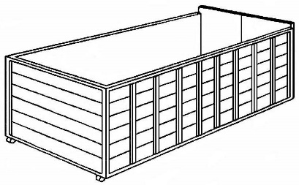
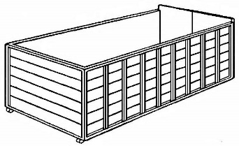

10 CUBIC YARDS

*** 2 ½’ high x 8’ wide x 14’ long
20 CUBIC YARDS
*** 4’ high x 8’ wide x 18’ long

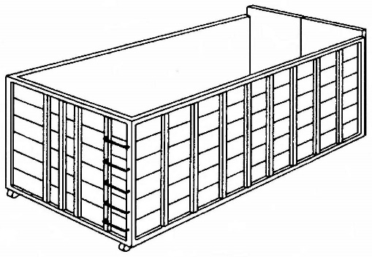
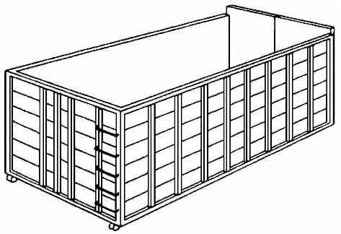

30 CUBIC YARDS
*** 5’ high x 8’ wide x 20’ long
40 CUBIC YARDS
*** 6 ½’ high x 8’ wide x 22’ long

MISCELLANEOUS INFORMATION
Mission Trail Waste Systems, Inc. (408) 727-5365
www.missiontrail.com/santaclara
customerservice@missiontrail.com
City of Santa Clara Utility Dept (Street Permits) (408) 615-2300
City of SC Traffic Engineering (Permit Application) (408) 615-3000
engineering@santaclaraca.gov
Fees & Special Charge Rates:
Driver and Equipment Time $252.80 / per hour (1 hr min. charge)
Saturday Service (Roll-Off Only) $471.89 / each
Relocation $252.80 / per box
“Emergency Load” (Same day service; Roll-Off Only) $252.80 / per hour (1 hr min. charge; only if available)
Box Extension (per week; MUST APPLY 24 hrs. PRIOR
TO SCHEDULED REMOVAL) $55.00

SAFETY WARNINGS – LOOSE BOXES ONLY

- NO DIRT OR CONCRETE

- DO NOT OVERLOAD / (Water-Level ONLY)

- DOORS MUST CLOSE AND LOCK AT TIME OF PICKUP

- IF PLACING BOX IN DRIVEWAY, I HAVE MEASURED TO MAKE SURE IT COMPLETELY FITS & DOES NOT BLOCK THE SIDEWALK

- BOX MUST BE EVENLY LOADED

- BOX WILL BE REMOVED ON THE 7TH DAY

- WE DO NOT GAURANTEE TIMES

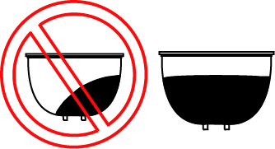

Signature: Print Customer Name:
MISCELLANEOUS INFORMATION

Mission Trail Waste Systems, Inc. (408) 727-5365
www.missiontrail.com/santaclara
customerservice@missiontrail.com
City of Santa Clara Utility Dept (Street Permits) (408) 615-2300
City of SC Traffic Engineering (Permit Application) (408) 615-3000
engineering@santaclaraca.gov
Fees & Special Charge Rates:
Driver and Equipment Time $252.80 / per hour (1 hr min. charge)
Saturday Service (Roll-Off Only) $471.89 / each
Relocation $252.80 / per box
“Emergency Load” (Same day service; Roll-Off Only) $252.80 / per hour (1 hr min. charge; only if available)
Box Extension (per week; MUST APPLY 24 hrs. PRIOR
TO SCHEDULED REMOVAL) $55.00

SAFETY WARNINGS – CONCRETE / ROCK / DIRT BOXES ONLY (10 Yd ONLY)

- DO NOT OVERLOAD / (Water-Level ONLY)

- DOORS MUST CLOSE AND LOCK

- BOX MUST BE EVENLY LOADED

- WE DO NOT GAURANTEE TIMES

- BOX WILL BE REMOVED ON THE 7th DAY.
(ie. Delivered on a Tuesday = Removed on following Tuesday)

Signature: Print Customer Name:

